1. Create a Virtual Machine with 1 vCPU, 2GB RAM and 15GB storage disk using a Type 2 Virtualization Software

**Solution:**

Select hard disk capacity:

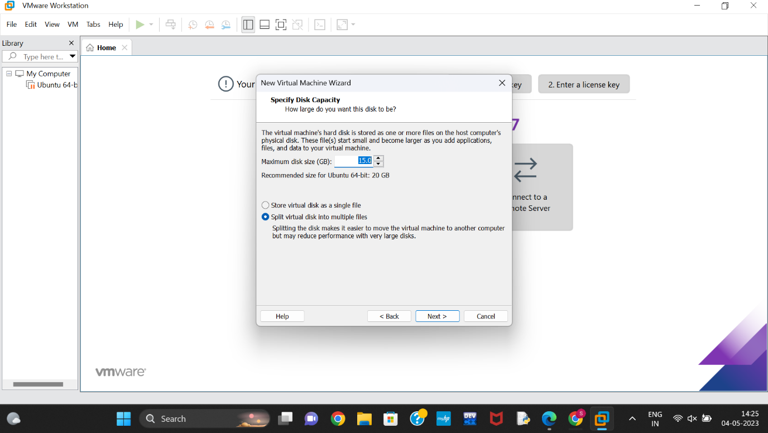

Select RAM capacity:

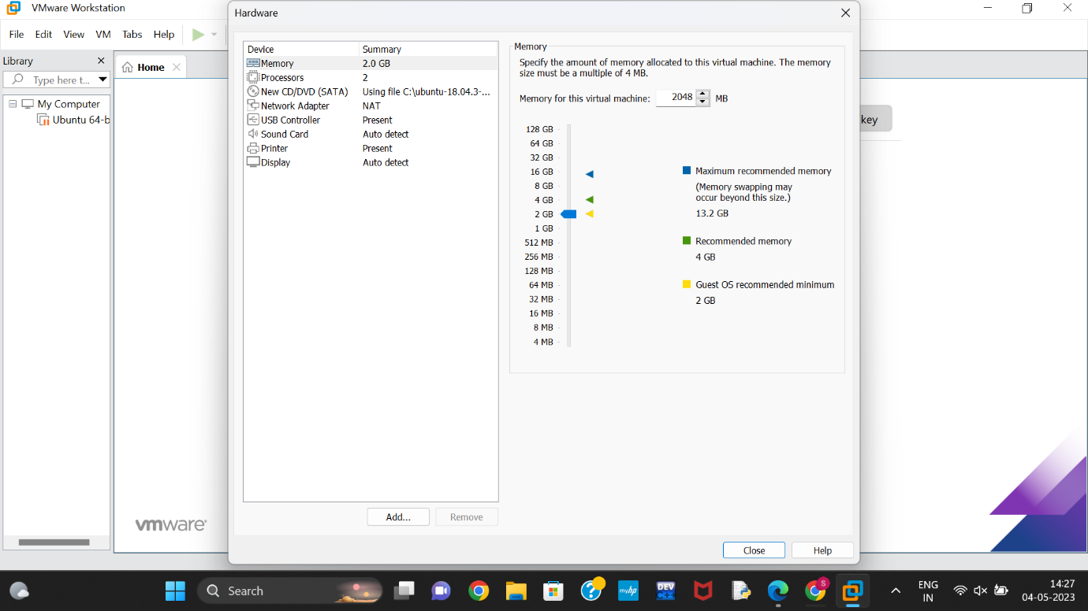

Personalize CPUs:

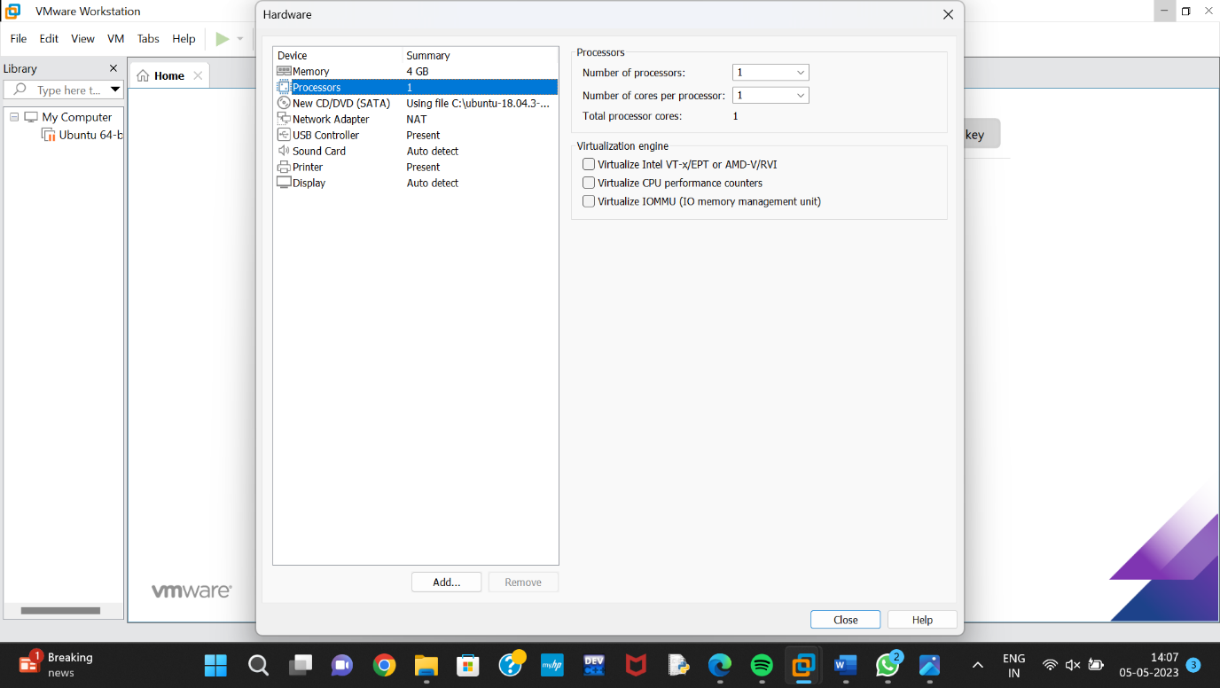

Final Virtual Machine:

